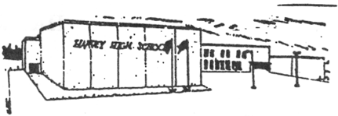 HARVEY HIGH NEWS
Building Community
Our staff and students are once again supporting the Harvey Lions Club Christmas Food Box Program and the McAdam/Harvey Food Bank. We are currently collecting non-perishable food items. The Lions will pick up our donation on December 22, 2016. Many members of our community benefit from this wonderful project.

Fundraising
The cheese fundraiser was a great success. We are planning on ordering once again in the spring right before Easter. We have had excellent feedback on the product. Thank you for your continued support.

Athletics
Basketball season is under way with our high school and middle school teams participating in games and tournaments. Please check the “Extracurricular-Athletics” link on the HHS website for team schedules and weekly updates. Remember when attending school events that the front along the school is a designated FIRE LANE. Please park in the lot behind the cement barrier.
CALENDAR OF EVENTS
Dec. 21 MADD School Assembly
Dec. 23 Last day of school before Christmas- Half day for students
Jan. 9 Teachers’ Professional Learning- No students
Jan. 10 Students return after Christmas Break
Jan. 23-27 High School Exams
Jan. 30, 31 Turnaround Days
Feb. 1 High School Second Term Begins
Feb. 24 Teachers’ Professional Learning- No students
Mar. 6-10 March Break
Apr. 10 Teachers’ Professional Learning and Parent/Teacher Interviews- No students
Apr. 28 Teachers’ Professional Learning- No students
May 5 Subject Council- No students
May 22 Victoria Day
June 23 Last day of classes- Graduation

HAPPY HOLIDAYS!

